4DS framework for sustainable production
A case study in Additive Manufacturing
Ottavia Aleo (M.Sc.) ^{a,c}, Dr.ir.Paola Ibarra-Gonzalez ^{b}, Dr.Paul Victor Osswald ^{c}, Prof.Dr.-Ing.Johannes Fottner ^{b}
ª Chair of Material Handling, Material Flow, Logistics, Technical University of Munich Boltzmannstraße 15, 85748 Garching, Germany
^{b} Faculty of Technology, Policy, and Management, Delft University of Technology
Jaffalaan 5, 2628 BX Delft, The Netherlands
^{c} BMW Group Petuelring 130, 80809 Munich, Germany

Abstract Improving sustainability in industrial production requires holistic integration of environmental, economic, social, and technical indicators into decision-making processes. Most sustainability frameworks in literature emphasize environmental performance, while underrepresenting technical feasibility and economic viability, which are critical for industrial implementation. This study introduces a structured four-dimensional sustainability framework (4DS) integrating technical, environmental, economic, and social dimensions to support informed decision-making in industrial contexts. The framework is applied to the mechanical recycling of Polyamide 12 (PA12) waste generated from automotive prototyping and its reuse as filament for Material Extrusion (MEX). Multiple recycling pathways are designed and compared, differing in logistical configuration and material composition. Recycled PA12 filaments produced from different flake/powder ratios are experimentally evaluated through tensile testing. Filaments produced from old PA12 powder without flakes generally exhibit more stable mechanical behaviour and improved printability compared to mixed flake/powder formulations, which show increased mechanical properties variability. The experimental results are integrated into a quantitative sustainability assessment and a multicriteria decision analysis to account for company-specific priorities. The findings demonstrate that the most suitable recycling pathway does not necessarily correspond to the lowest-cost or lowest-impact option when individual sustainability dimensions are considered. The results highlight the importance of balanced, context-specific sustainability assessment that integrates experimental material performance with environmental, economic, and social criteria to identify implementable industrial recycling solutions.
Introduction
Additive Manufacturing (AM) has become an established technology in the automotive industry, particularly for prototyping and tooling, due to its design freedom, and suitability for complex polymer components. Among polymeric materials, Polyamide 12 (PA12) is widely used in automotive prototyping due to its mechanical properties and stable processing behaviour. However, the short service life of prototypes and accelerated development cycles result in a continuous generation of PA12 waste that is rarely reintegrated into new material streams. This challenge has positioned AM prototyping at the intersection of material efficiency and sustainability assessment. In industrial production, sustainability is commonly described as a multidimensional concept integrating environmental, economic, and social objectives [1], [2]. Numerous frameworks based on this three-pillar model have been proposed, including business sustainability indicators [3], [4], circular economy approaches [5], life-cycle-based waste management assessments [6], textile recycling models [7], the European Commission’s Safe and Sustainable by Design framework [8], and the Triple Bottom Line concept [9]. While these approaches provide a robust basis for evaluating industrial systems, they often place limited emphasis on technical feasibility and process performance, which are essential for the industrial implementation and scaling of AM solutions.
In the automotive sector, plastics play a central role in lightweight design strategies driven by increasingly strict emission regulations [10], [11], with further growth expected due to frequent model updates and shorter product lifecycles [12]. Despite this extensive use, plastic waste management remains inefficient, with incineration remaining the dominant disposal route [13]. Plastic recycling is widely adopted to reduce industrial waste, even though it is more impactful than reuse-oriented strategies. Environmental assessments consistently show that recycling plastics requires substantially less energy than virgin material production [14], [15]. Carbon emission reductions from recycling range between 30% and 80%, depending on process type and energy sources [16]. Mechanical recycling is generally considered more economically viable and environmentally efficient than chemical recycling due to lower energy demand and reduced use of additives [17].
Within the AM research landscape, recycling studies have predominantly focused on material-level characterization rather than on integrated process or system-level assessments. Prior work has investigated recycled filaments derived from PET [18], Nylon 6 [19], and aluminium/plastic packaging waste [20], primarily evaluating mechanical and rheological properties. The most recycled polymers for AM include PLA, ABS, PET, HDPE, PP, and PS [21], while research on polyamides remains limited and does not address automotive waste streams. Existing studies on PA12 largely focus on powder reuse in Laser-based Powder Bed Fusion of Polymers (PBF-LB/P) processes, examining powder aging and closed-loop reuse strategies [22-27]. More recent contributions explored converting residual PBF-LB/P powder into pellets or filaments suitable for Material Extrusion (MEX) [28-30]. However, the recycling of end-of-life PA12 parts from automotive AM prototyping has not been systematically investigated. Although PA12 filaments have been shown to withstand multiple remelting and shredding cycles without significant mechanical degradation [31], the effects of shredding and reprocessing printed components remain insufficiently understood.
The present study is motivated by an industrial problem identified at an automotive prototyping facility, where a continuous and increasing amount of PA12 powder waste is generated as byproduct from PBF-LB/P processes, leading to high disposal costs, loss of valuable material, and environmental impacts associated with transportation and end-of-life treatment. Economically, waste disposal costs are significant and regulatory pressure on waste management is increasing. From an environmental perspective, PA12 waste contributed to non-negligible CO₂ emissions. Against this background, this work develops an AM oriented assessment sustainability framework that integrates technical performance with environmental, economic, and social considerations. The framework is applied to an industrial case study on the mechanical recycling of PA12 waste from automotive AM prototyping into filament for MEX, targeting tooling applications such as jigs and fixtures. For the technical assessment, this study includes an experimental evaluation of recycled PA12 filaments produced from different compositions for old powder and old prototypes, focusing on printability and mechanical performance. Tensile testing of MEX-printed specimens is conducted to assess material stability and variability resulting from the recycling process. For the economic, social, and environmental assessment, a set of dimension-specific indicators is defined to capture different impacts associated with the alternative recycling pathways. A multi-criteria decision-analysis approach based on the Best-Worst Method (BWM) [32] is employed to evaluate alternative recycling pathways in alignment with industrial priorities. By linking experimental material performance with AM process requirements, sustainability indicators, and operational constraints, the study contributes to the development of industrially viable recycling strategies for AM.
Materials and Methods

Framework for Sustainable Production
For the scope of the work, a structured assessment framework was developed, based on four dimensions of sustainability (4DS): technical, environmental, economic, and social (Figure 1), to support the decision-making process.
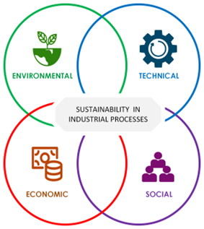
Figure 1: Four dimensions of sustainability (4DS). Picture by the author. Icons by Athok from Noun Project [33].
The technical dimension addresses factors related to the properties of the materials under consideration. The environmental dimension encompasses impacts associated with resource use, and emissions, adopting a life cycle perspective [34]. The economic dimension considers aspects related to costs, investments, and economic feasibility [35], [36]. The social dimension includes organizational and human-related factors, such as working conditions, and stakeholder acceptance. The framework follows ten sequential steps designed to include the 4DS and ensure transparency, adaptability, and reproducibility (Figure 2). These include problem definition, analysis of the Business as Usual (BaU), definition of objectives and indicators, system boundary definition, pathway design, indicator screening, qualitative and quantitative assessment, multi-criteria decision analysis with the adoption of the BWM, and final pathway selection. The framework is built on the Lowell Indicator Framework developed by the Lowell Center for Sustainable Production [3], [4]. Objectives and indicators were selected following established approaches for industrial sustainability assessment [37-41].
System boundaries were defined by direct constraints (e.g., regulatory, geographical, operational) and indirect factors (e.g., stakeholder relations, strategic positioning) [42]. Pathways differ in material composition, and logistical setup. The qualitative assessment was performed through the analysis of dimension-specific indicators to screen alternatives and exclude technically or organizationally infeasible options. Performance evaluation was then conducted through quantitative analysis of the selected indicators. The BWM was applied to support the weighting of assessment dimensions and aid in the selection of the most suitable pathway, leading to a final decision aligned with the defined evaluation criteria.
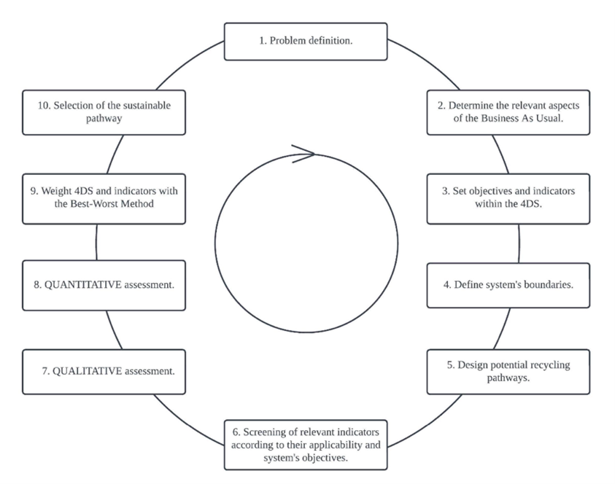
Figure 2: Framework for evaluating sustainable recycling pathways in automotive prototyping processes. Picture by the author.

Case study and recycling pathway definition
This section covers from the problem definition to pathway design (Step 1-5). The framework was applied to the case study of mechanical recycling of PA12 waste from automotive prototyping from PBF-LB/P processes. After repeated reuse cycles, PA12 powder and end-of-life prototype parts no longer meet production requirements and are treated as waste. The objective was to evaluate alternative pathways to convert this waste (both old powder and discarded prototypes) into different filaments suitable for MEX for tooling applications, and through the implementation of the framework, assess their performance and select one specific pathway.
Based on the company’s sustainability objectives, technical, economic, social and environmental indicators were selected. An initial indicator set was defined across the 4DS to reflect relevant performance and operational feasibility. For the assessment, system boundaries were defined to include the collection, processing (recycling), and reintegration of recycled material, distinguishing between internal and external recycling pathways. Internal recycling involves material processing within the originating production system, whereas external recycling relies on third-party processing, introducing additional logistics but offering access to specialized infrastructure.
Six recycling pathways were defined, differentiated by internal versus external recycling and by the ratio of shredded PA12 parts (flakes) to old PA12 powder. Pathways included internal recycling without mixing (A), and with mixing (B), external recycling abroad without mixing (C), and with mixing (D), external recycling domestically without mixing (E), and with mixing (F). Mixing ratios ranged from 90/10 to 50/50 flakes-to-powder. All pathways included collection, manual sorting of PA12 parts, removal of attachments, shredding to approximately 6 mm flakes (Figure 3), and drying at 80 °C prior to extrusion. Shredding in-house was performed using a shredder (Figure 4; specifications in Table 1).
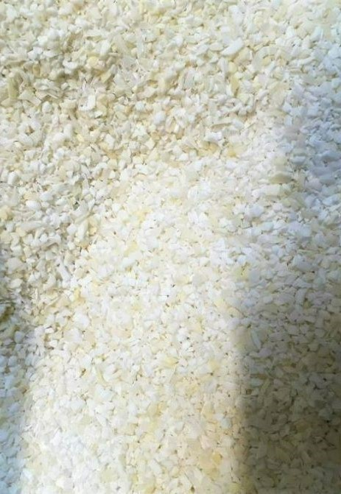 | 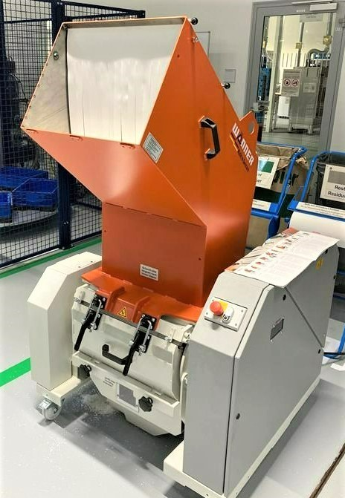
Figure 3: PA12 material after shredding process (6mm flakes). Picture by the author. | Figure 4: Polymers parts shredder. Picture by the author.
Table 1: Technical characteristics of the shredder purchased for recycling [43].
Characteristics | Value
Type | D30.50
Motor power | 7,5 kW
Voltage supply | 400 V/50 Hz
Rotor speed | 450 rpm
Stator knives | 2
Rotor knives | 6
Cutting chamber opening | 395 mm x 500 mm
Sieve size | 5 – 15 mm
Throughput | > 250 kg/h
Weight | 600 kg
Noise emission value | < 85 dB

Assessment and selection of the recycling pathway
This section covers from the screening of the indicators until the selection of the best recycling pathway after the assessment (Step 6-10). Indicators previously selected were screened based on data availability, relevance to AM end-use, and ability to differentiate between pathways. Non-discriminatory indicators were removed prior to qualitative and quantitative assessment. For the final set, technical indicators included recycled material quantity, printability rate, transport distance, energy use, process lead time, and variability in tensile properties. Environmental indicators included transport and equipment related CO₂ emissions and noise pollution. Economic indicators captured investment requirements, and operating and disposal costs, while social indicators covered workers acceptance, training required, and ease of management. Qualitative pre-screening was performed using the indicators defined to assess the feasibility of the initially defined recycling pathways. The assessment focused on technical practicability and organizational compatibility within the defined system boundaries. Pathways associated with limited feasibility were excluded (the ones involving internal recycling), reducing the pathway set to the four most promising options (C, D, E, F) for further analysis.
In line with the defined indicators, economic, social, and environmental performance were evaluated based on experimental calculations, operational data from the facility, and secondary sources such as emission factors. Technical performance was assessed experimentally through tensile testing of MEX-printed specimens produced from recycled PA12 filaments, using tensile strength and elongation at break as indicators of material stability. The resulting indicator values were aggregated and weighted using the BWM to reflect company-specific sustainability priorities and support pathway selection.

Experimental setting and validation of the recycled material
Material suitability for MEX was assessed using a BCN3D Sigma D25 printer (Figure 5; specifications in Table 2) operating under an open-material system. Type 1A specimens were used for tensile testing of the materials (Figure 6; dimensions in Table 3) [44].
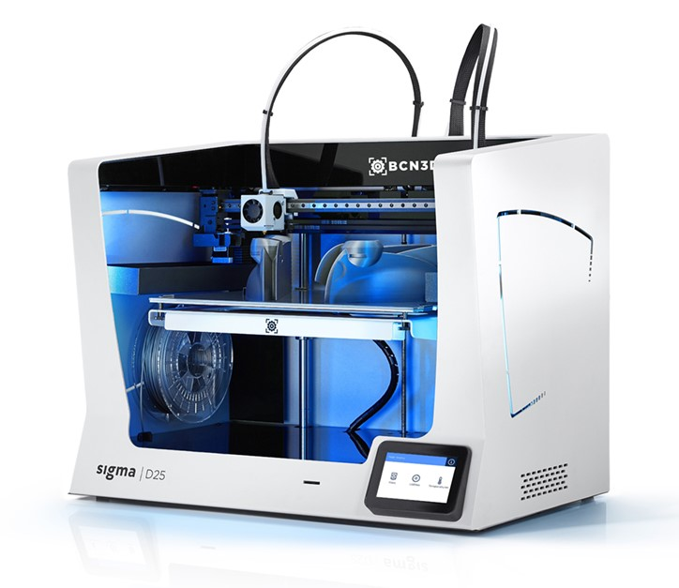
Figure 5: BCN3D Sigma D25 [45].
Table 2: Main technical characteristics of the MEX printer BCN3D Sigma D25 [45].
Characteristics | Value
3D printing technology | Material Extrusion (MEX)
Architecture | Independent Dual Extruder (IDEX)
Printing volume | 420mm x 300 mm x 200 mm
Number of extruders | 2
Supported files | *. gcode
Nozzle diameter | 0,4 mm — 0,6 mm — 0,8 mm
Filament diameter | 2,85 ± 0,05 mm
Open filament system | Yes
File preparation software | BCN3D Stratos

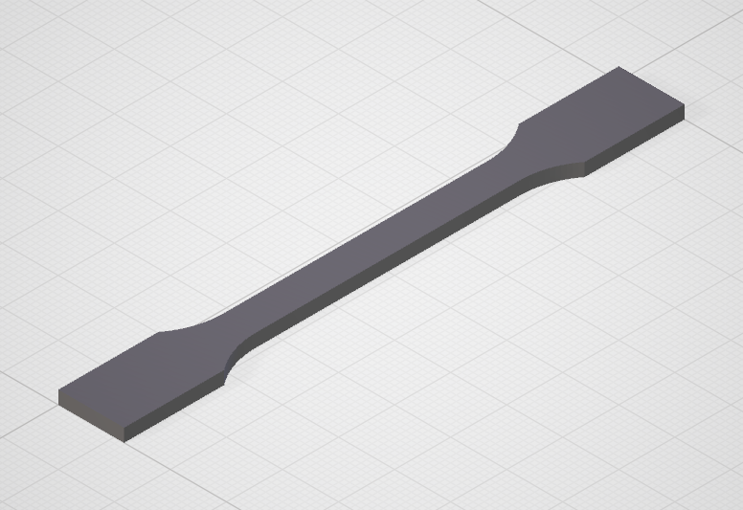 | 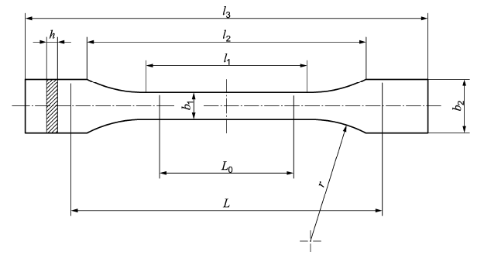
Figure 6: Standard test specimen Type 1A in DIN EN ISO 527-2 [44]: (a) 3D model (left) and (b) technical dimensions (right).
Table 3: Specimen Type 1A dimensions (ISO 527-2:2012) [44].
Symbol | Characteristics | Value
l₃ | Total length | 170 mm
l₁ | Length of the narrow parallel part | 80 ± 2 mm
r | Radius | 24 ± 1 mm
l₂ | Distance between the wide parallel sides | 109,3 ± 3,2 mm
b₂ | Width at the ends | 20,0 ± 0,2 mm
b₁ | Width of the narrow part | 10,0 ± 0,2 mm
h | Preferred thickness | 4,0 ± 0,2 mm
L₀ | Measuring length | 75,0 ± 0,5 mm
L | Initial spacing of the terminals | 115 ± 1 mm
A preliminary parameter study was conducted to define a standard print job. Four print jobs were executed using identical PA12 filament while varying infill density and infill pattern, identified as key parameters influencing mechanical performance in MEX [46]. Filament was dried at 80 °C for at least three hours prior to printing to mitigate moisture effects [47]. Eleven specimens per job were tested, and tensile strength and elongation at break were evaluated (Figure 7). Tensile testing was conducted under controlled environmental conditions (22 °C, 50% Relative Humidity) using an in-house testing machine (Figure 8). The configuration with 100% infill density and a 45°-line pattern yielded the highest mechanical performance and was selected for subsequent validation. For the official printing process of the different filaments obtained from the remaining recycling pathways, five specimens per job were printed (Figure 9).
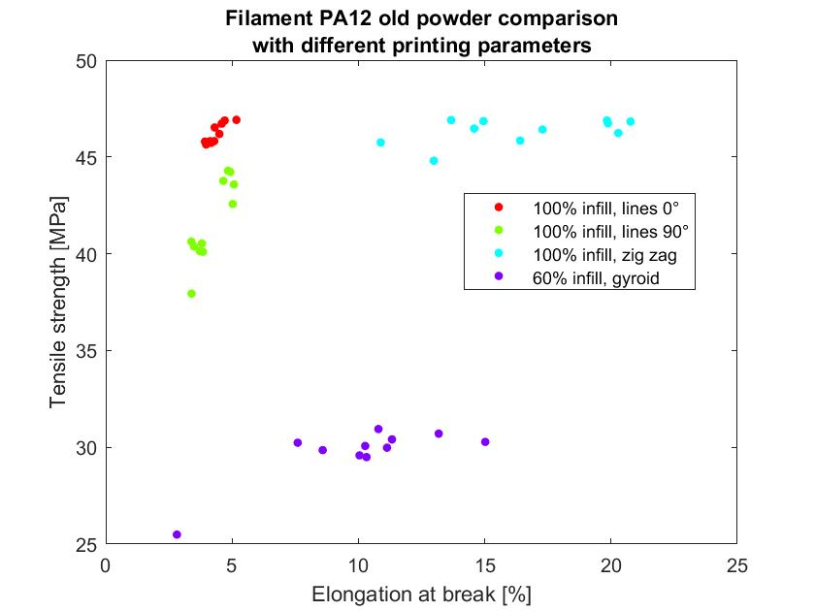
Figure 7: Elongation at break VS Tensile strength for PA12 filament with different infill characteristics. Picture by the author.
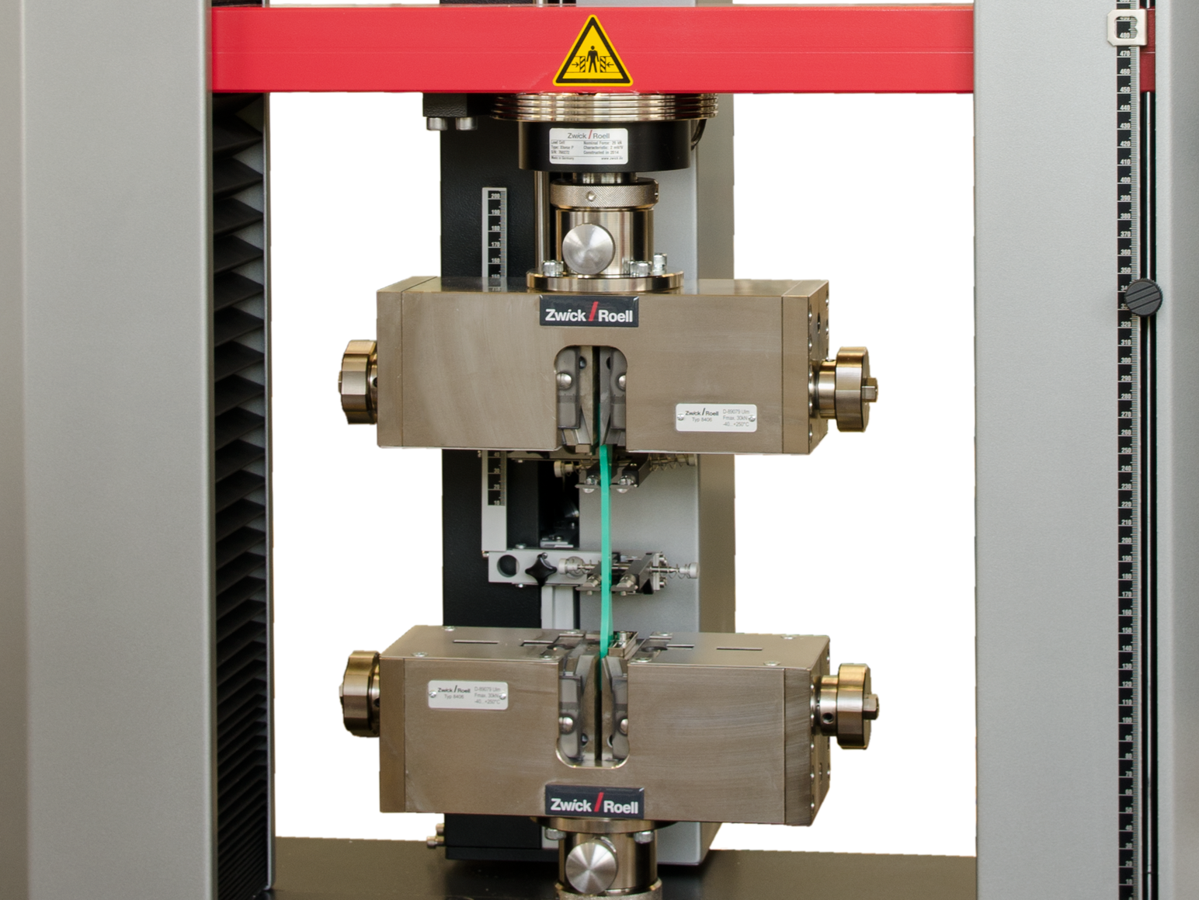
Figure 8: Tensile testing machine adopted at the company's facility [48].
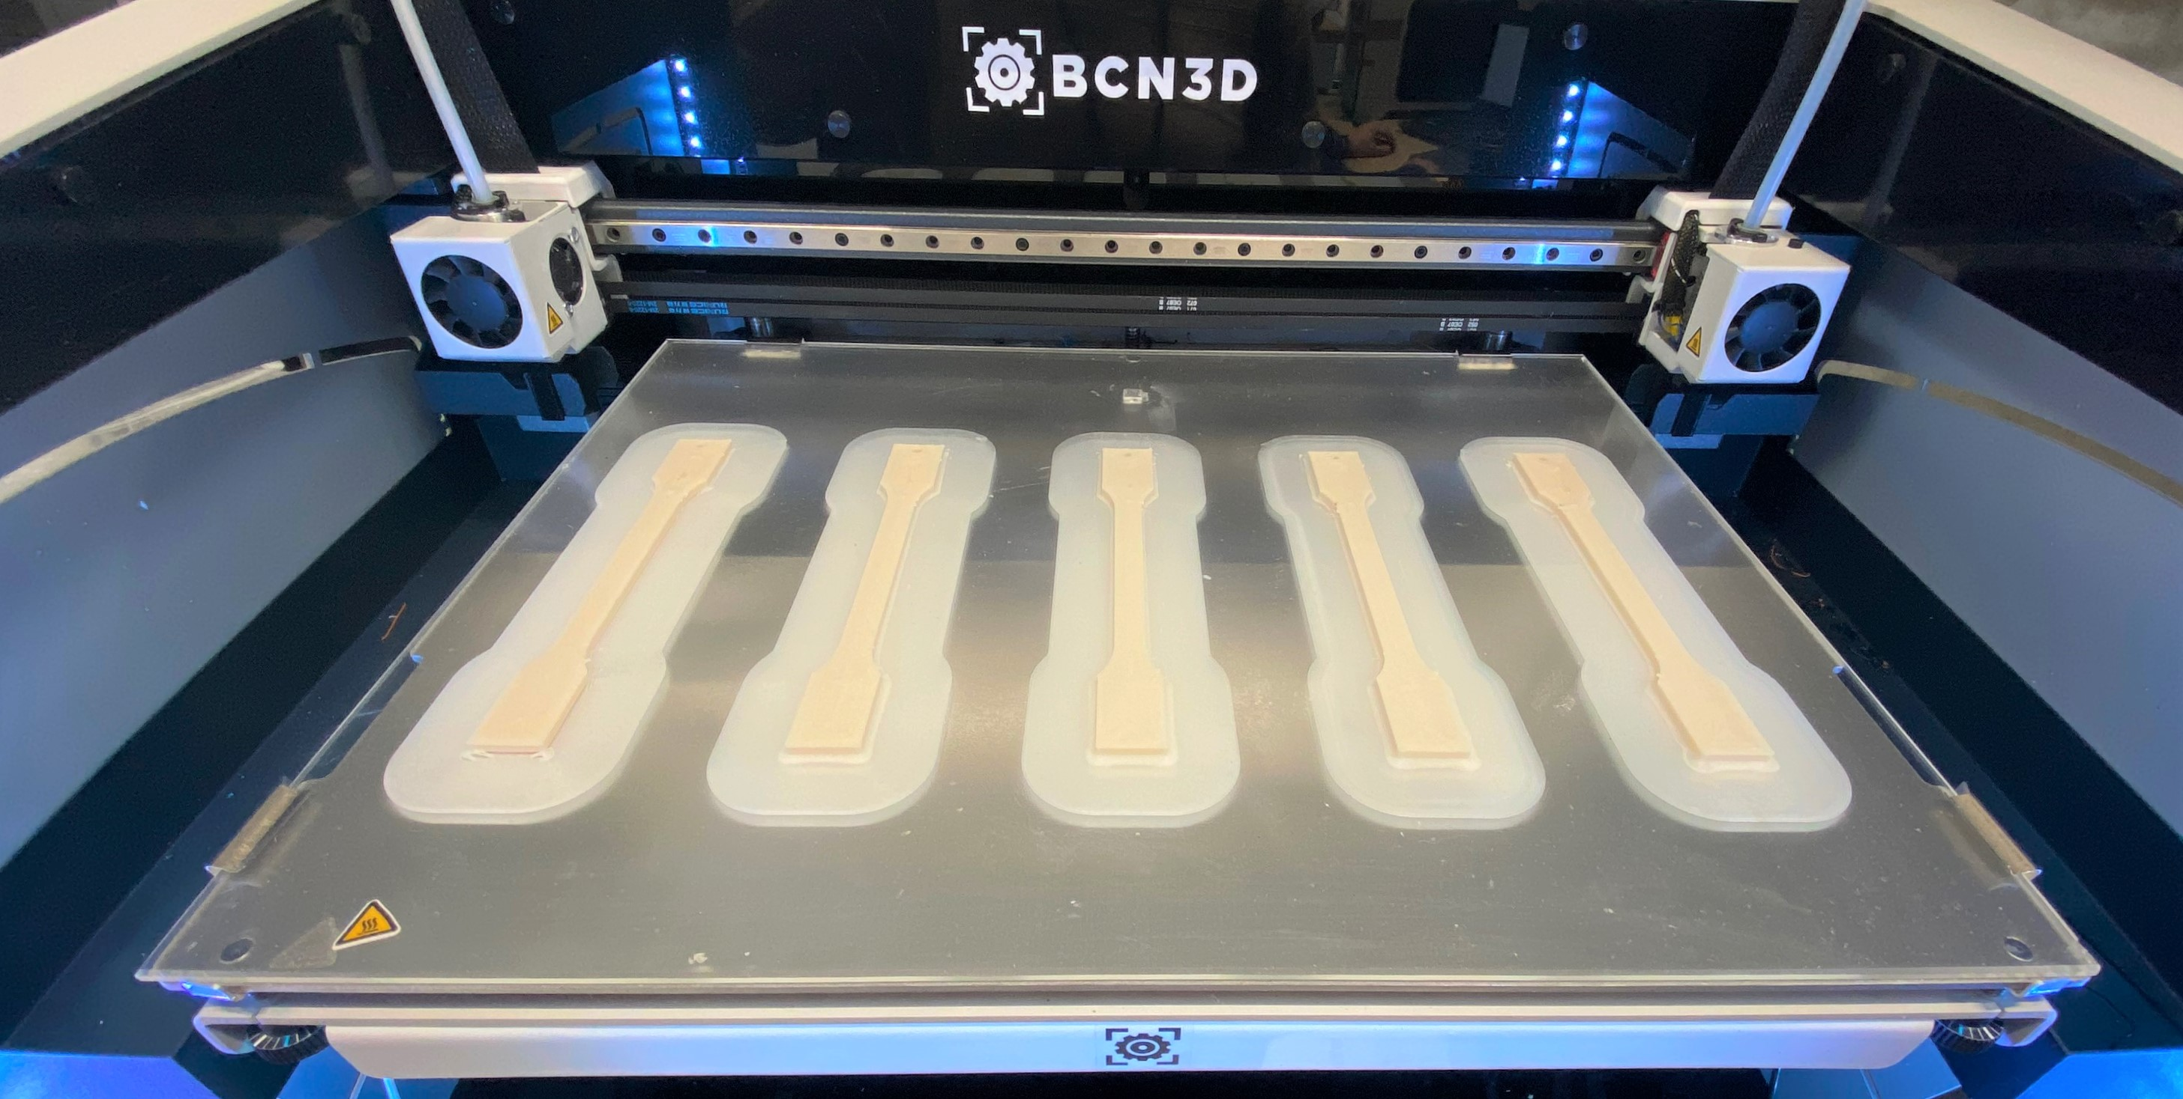 | 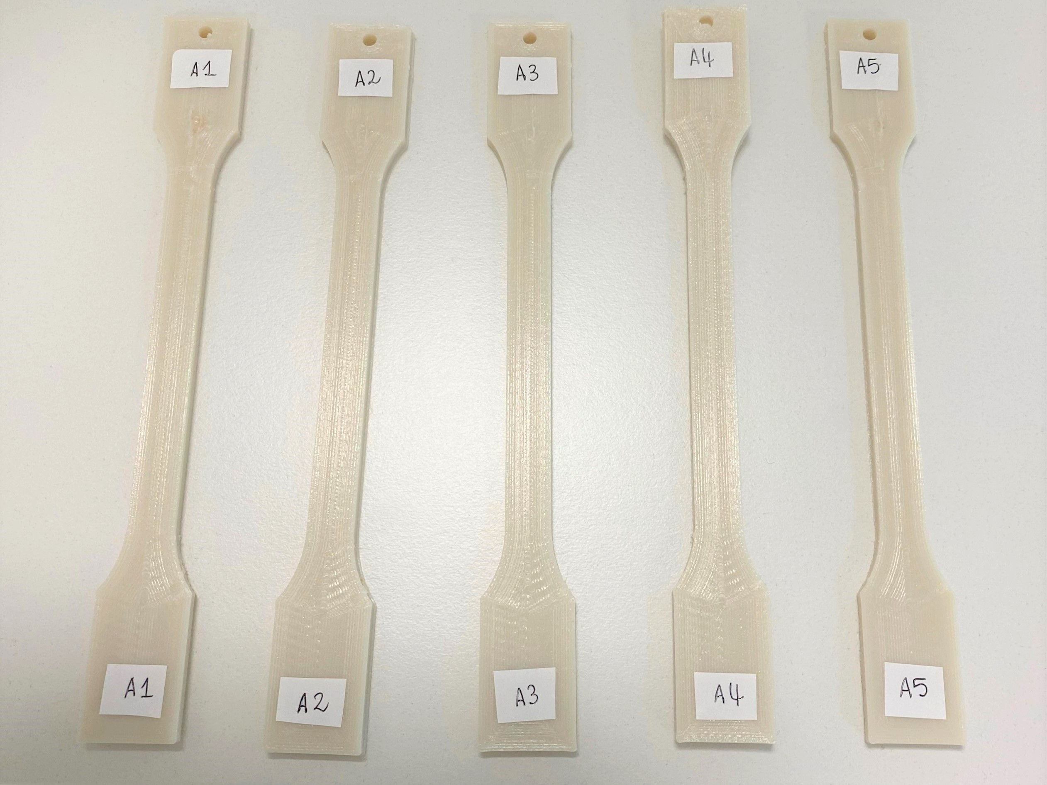
Figure 9: Material validation procedure: (a) Standard print job (left) and (b) Test specimens labeled after the print job (right). Picture by the author.
For the quantitative assessment, technical indicators were derived from experimental tensile testing results of recycled PA12 filaments, reflecting material stability and mechanical variability. Environmental and economic indicators were calculated using operational data in combination with literature-based energy and emission factors. Social indicators were calculated based on process-related parameters, interviews and surveys among the production employees. Following the quantitative assessment on the selected indicators, the BWM was applied across the dimensions to align the results with the company’s priorities. The results of the calculations obtained from the quantitative assessment and the BWM application are discussed immediately below.
Results
Following the experimental setup validation for the recycled PA12 filaments, this section presents the results of the quantitative assessment and the subsequent evaluation of the selected recycling pathways. The experimental findings are then incorporated into the sustainability assessment and multi-criteria decision analysis to support comparison between pathways.

Mechanical testing results
Internally produced filaments (Pathways A and B) exhibited unstable diameter and inhomogeneous composition, leading to feeding issues and under-extrusion during MEX printing. As a result, these pathways were excluded from further consideration. Externally produced filaments demonstrated consistent diameter and reliable printability (Figure 10), enabling mechanical testing.
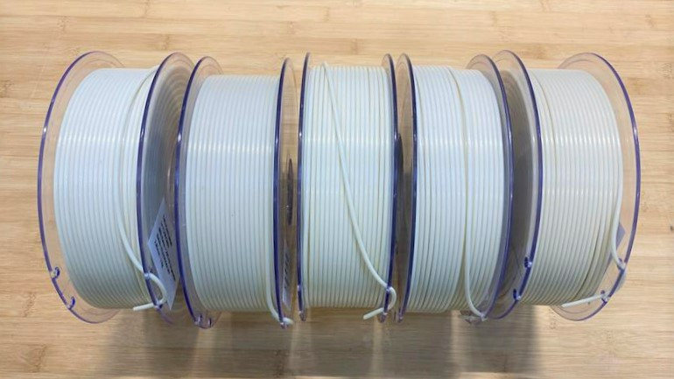
Figure 10: Recycled PA12 filament obtained through Pathways C and D. From right to left there are respectively 100% flakes (no mixing), 90% flakes, 80% flakes, 70% flakes, and 50% flakes. Picture by the author.
Tensile testing revealed significant variability in elongation at break across mixtures (Figure 11). In general, higher flake content was associated with increased elongation at break, although the 80% flake mixture deviated from this trend. No consistent fracture pattern was observed visually (Figures 12–16), indicating heterogeneity in recycled material quality.
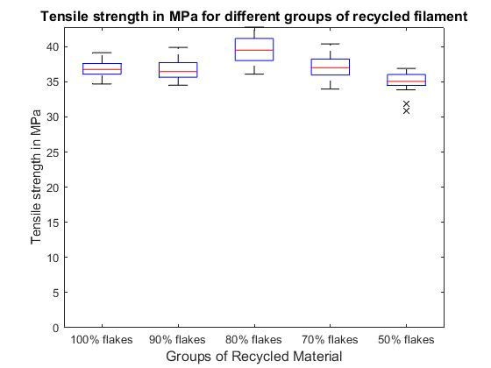 | 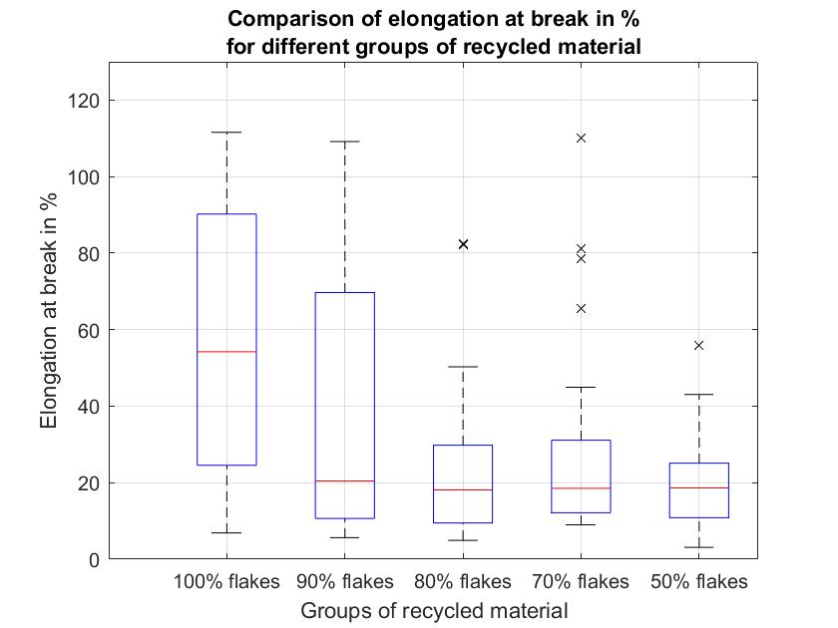
Figure 11: Tensile testing comparison results on the different mixtures for Pathways C and D: (a) Tensile strength (left) and (b) Elongation at break (right). Picture by the author.
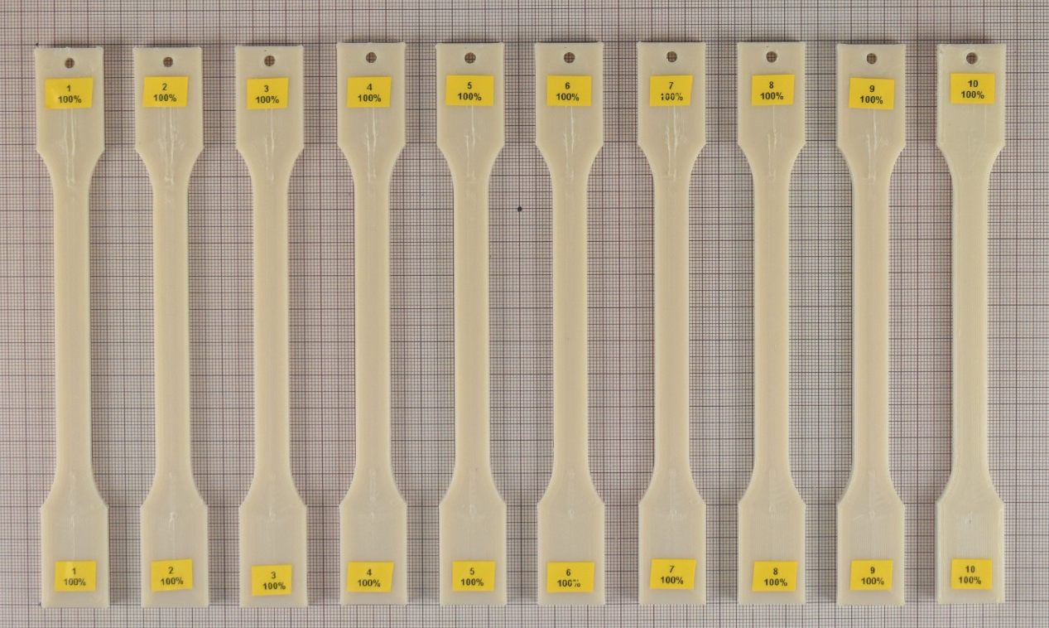 | 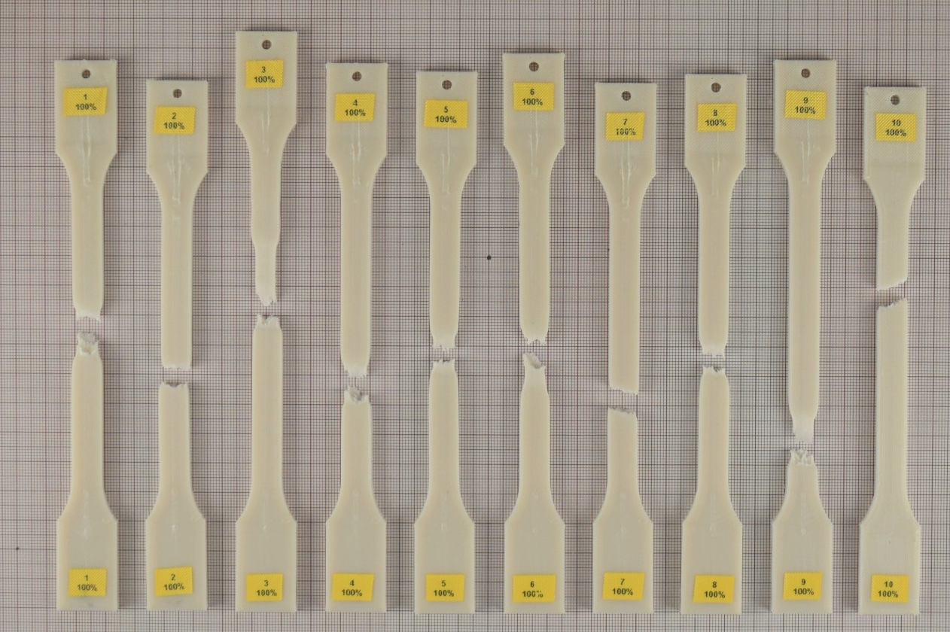
Figure 12: Test specimens before/after tensile testing - Filament 100% flakes content: (a) before (left) and (b) after (right). Picture by the author.
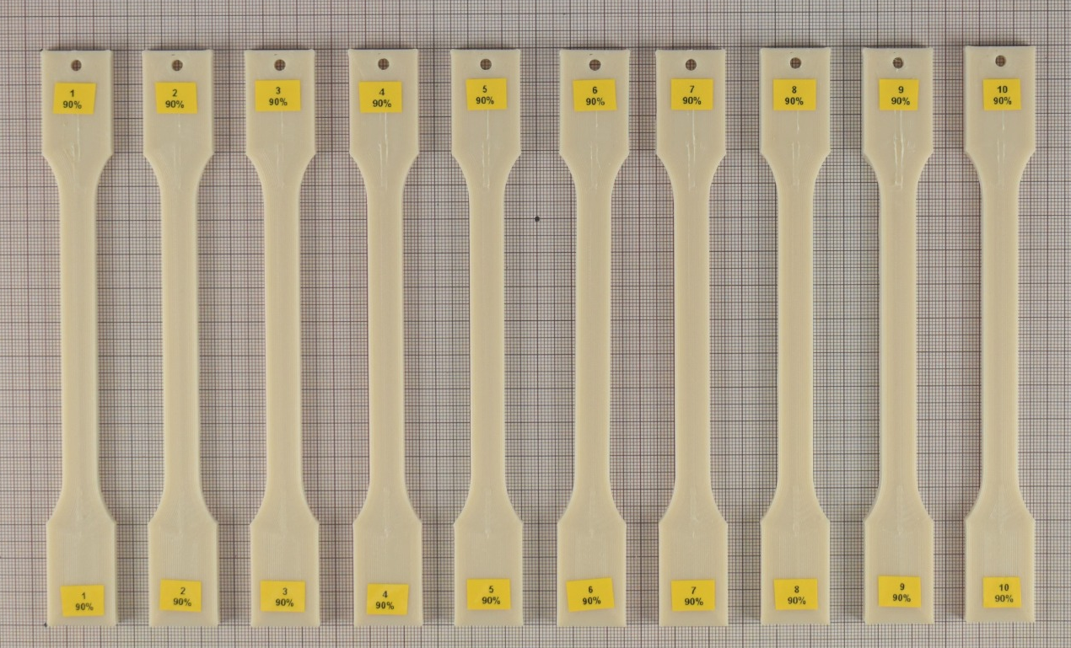 | 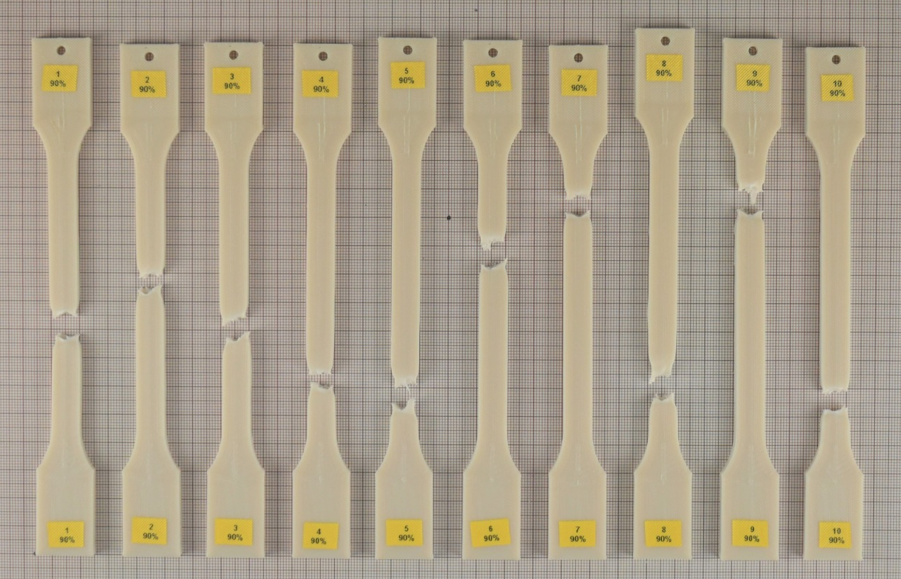
Figure 13: Test specimens before/after tensile testing - Filament 90% flakes content: (a) before (left) and (b) after (right). Picture by the author.

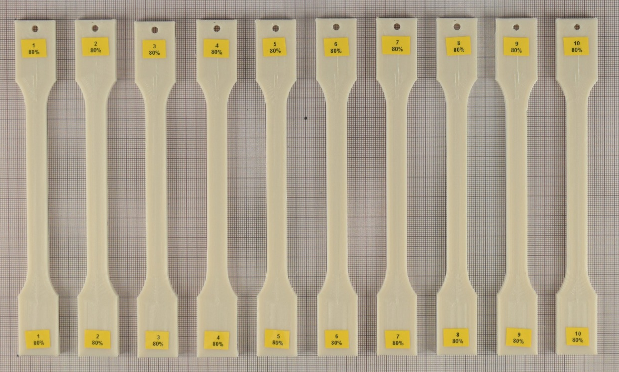 | 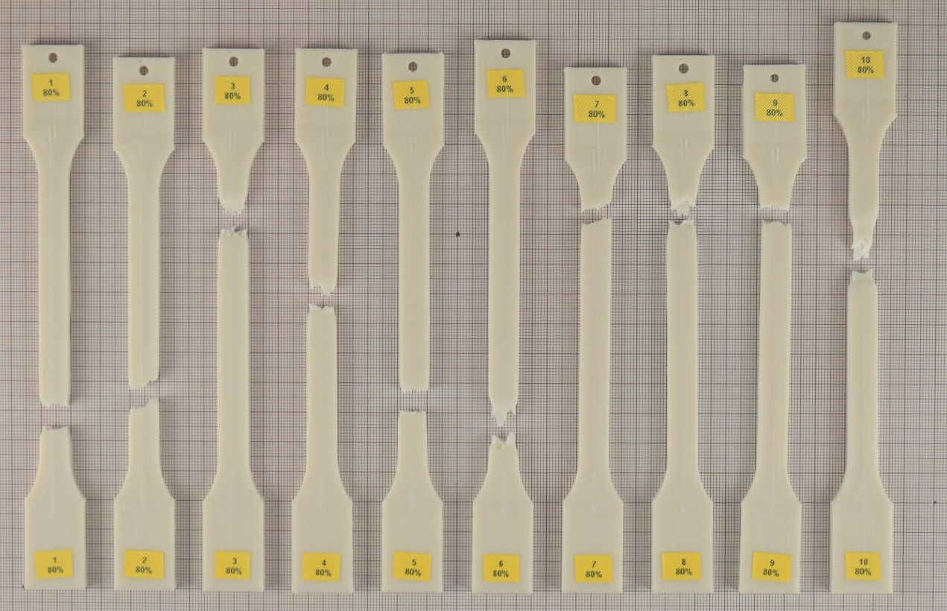
Figure 14: Test specimens before/after tensile testing - Filament 80% flakes content: (a) before (left) and (b) after (right). Picture by the author.
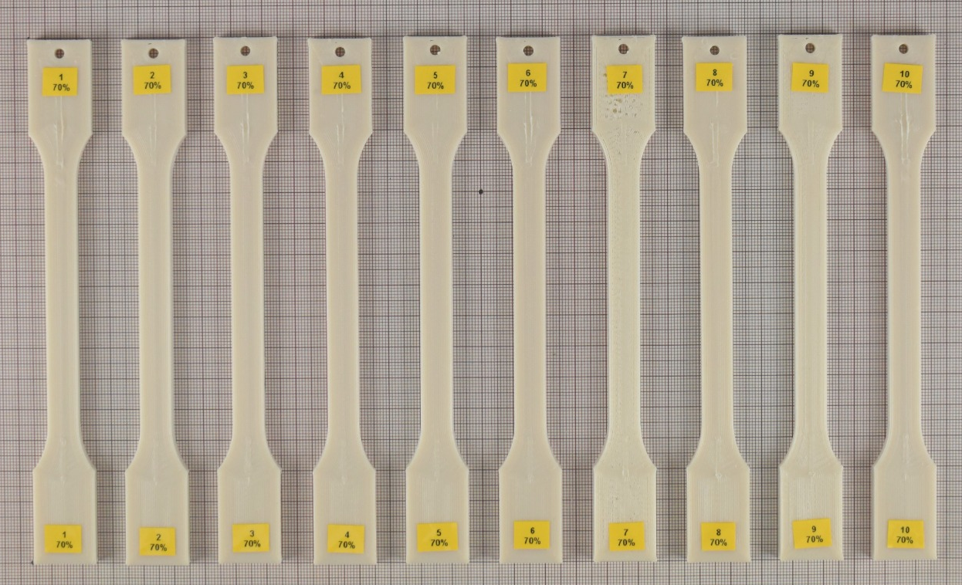 | 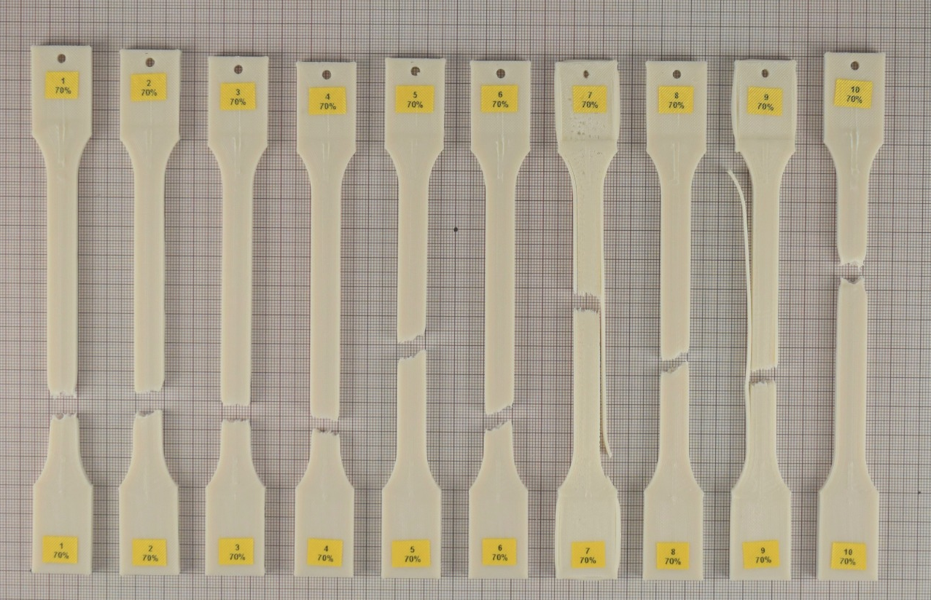
Figure 15: Test specimens before/after tensile testing - Filament 70% flakes content: (a) before (left) and (b) after (right). Picture by the author.
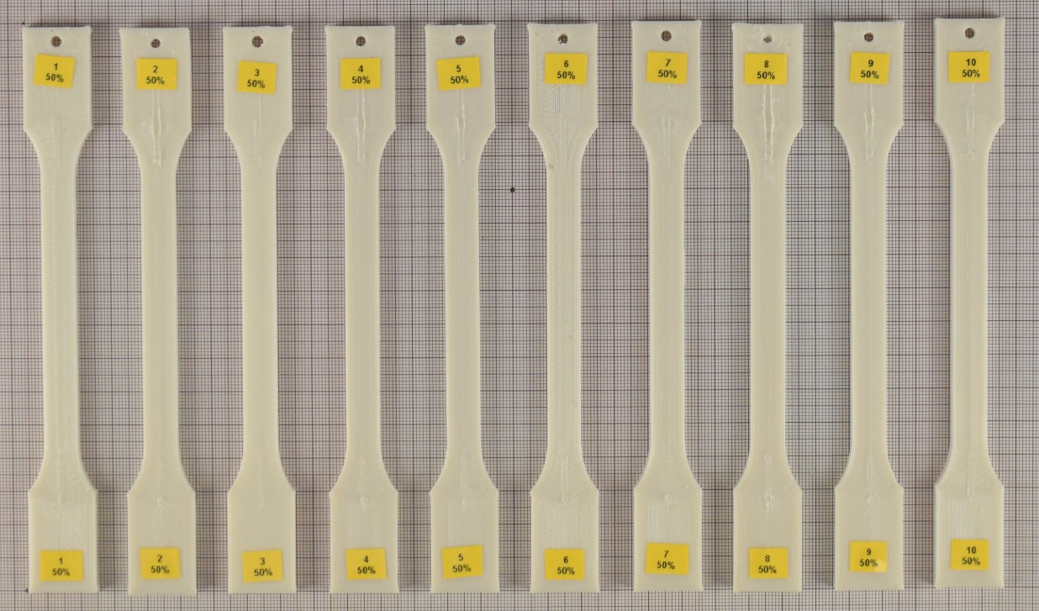 | 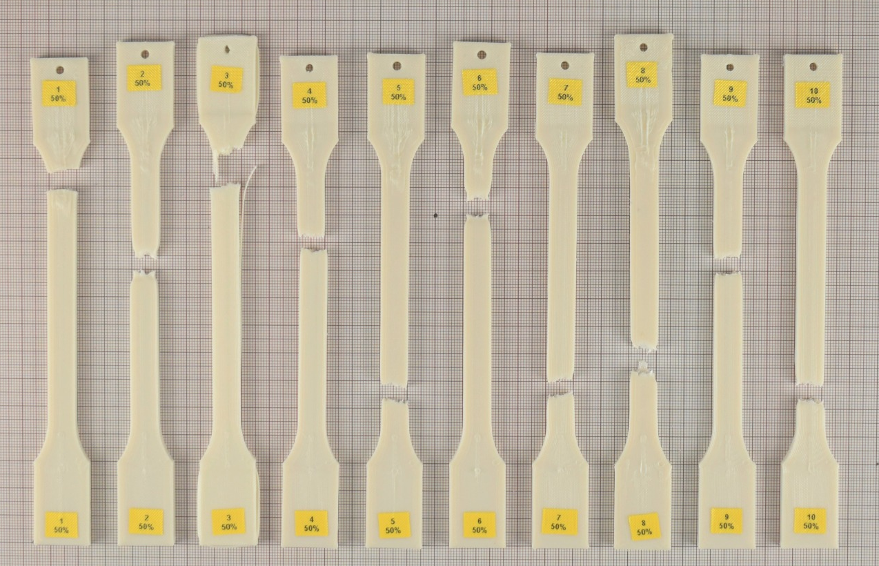
Figure 16: Test specimens before/after tensile testing - Filament 50% flakes content: (a) before (left) and (b) after (right). Picture by the author.

Quantitative assessment results
Quantitative indicator results for the selected pathways (C, 4D, E, 4F) are summarized in Table 4. All selected pathways showed substantial improvements compared to the baseline disposal scenario, particularly in reduced waste generation and avoided disposal impacts. The quantitative assessment revealed differences in economic, environmental, social, and technical performance among the evaluated recycling pathways.

Table 4: Quantitative assessment with real data.
Indicators | Unit | C | D | E | F
Recycled flakes quant. | [kg/spool] | 1.67 | 0.63 | 1.67 | 0.63
Recycled powder quant. | [kg/spool] | 0 | 0.63 | 0 | 0.63
SD elongation at break | [%] | 36.03 | 12.92 | 36.03 | 12.92
Total vehicle distance | [km] | 13814 | 14553 | 3818 | 4292
Energy used for transp. | [kWh] | 127.08 | 416.44 | 87.93 | 274.95
Time required | [days] | 67 | 67 | 34 | 34
CO₂ emissions transp. | [kgCO₂eq] | 46.76 | 129.44 | 22.72 | 75.51
CO₂ emissions equipment | [kgCO₂eq/spool] | 0.0114 | 0.0043 | 0.0114 | 0.0043
Noise duration | [min/spool] | 0.4 | 0.15 | 0.4 | 0.15
Preference (pathway) | [%] | 84.62 | 15.38 | 84.62 | 15.38
Preference (filament) | [%] | 67 | 33 | 67 | 33
Ease of management | [%] | 0 | 0 | 100 | 100
Number of manual steps | [N] | 3 | 5 | 3 | 5
Technical performance differed across pathways as a function of material stability and process robustness, with recycled PA12 filaments showing varying mechanical behavior depending on the flakes/powder ratio. Externally implemented pathways exhibited higher transport energy use and CO₂ emissions due to additional logistical steps, whereas internally implemented routes showed reduced transport distances and shorter process times. Economic performance varied primarily with process time and material output. Social performance varied with manual handling requirements, noise exposure, and organizational complexity, with differences observed between internally and externally implemented routes.

Multi-criteria decision analysis and pathway ranking
Application of the BWM indicated that technical and economic dimensions carried the highest weight, followed by social and environmental dimensions. Weighted aggregation of indicator scores showed that Pathway E (external domestic mechanical recycling, 100% flakes) achieved the highest overall score, combining robust technical performance, favorable stakeholder acceptance, and good environmental performance in comparison to the other pathways. Pathway C achieved strong technical and economic scores but was penalized by higher transport-related environmental impacts. Mixed-material pathways (D, F) achieved moderate overall performance but showed reduced controllability and integration. Overall, Pathway E was identified as the most suitable option for implementation, offering the most balanced trade-off between AM process reliability, operational feasibility, and system-level performance.
Discussion

Experimental methodology
The experimental methodology adopted in this study was designed to reflect industrially relevant conditions while maintaining sufficient standardization to allow comparability between recycled material variants. Tensile testing of MEX-printed specimens was selected as the primary characterization method, as it provides a well-established basis for evaluating mechanical performance of polymer-based additively manufactured materials and is commonly used in both academic and industrial contexts. The choice of tensile strength and elongation at break as key indicators was motivated by their sensitivity to material degradation, heterogeneity, and processing-induced defects, which are particularly relevant for mechanically recycled polymers. A standardized printing configuration was intentionally applied across all material variants to isolate the influence of material composition from process-related variability. In an industrial context, parameter optimization could partially compensate for material variability; however, the chosen methodology provides a conservative and robust assessment of material performance under fixed processing conditions.
Overall, the experimental methods used in this study support the objectives of the four-dimensional sustainability framework. Rather than aiming to demonstrate maximum achievable material performance, the experiments provide decision-relevant input on material stability, process robustness, and suitability for non-safety-critical tooling applications. This alignment between experimental design and decision-making requirements strengthens the integration of material testing into the broader sustainability assessment and supports the identification of practically implementable recycling pathways.

Interpretation of pathway performance and decision outcome
Application of the 4DS framework enabled a systematic comparison of PA12 recycling pathways differing in flakes-to-powder ratio and production location, integrating technical, environmental, economic, and social criteria. The comparison of recycling pathways indicates that sustainability performance is primarily influenced by logistical configuration and organizational complexity rather than by material processing alone. As summarized in Table 4, externally implemented pathways show higher transport-related energy use and CO₂ emissions due to additional logistics, negatively affecting their environmental performance, whereas internally implemented pathways benefit from reduced transport distances and shorter process times, resulting in more favorable economic and environmental indicator values. When these differences are integrated into the multi-criteria decision analysis, the BWM weighting assigns greater importance to technical and economic dimensions, amplifying the relative advantage of internally implemented routes. Social performance further differentiates the pathways, reflecting trade-offs between process transparency, operational control, and coordination effort.
The unweighted qualitative and quantitative assessments consistently identified Pathway E (based on 100% recycled flakes and fully domestic processing) as the most suitable option. This pathway combined the highest recycling efficiency with the shortest transport distance, resulting in the lowest transport-related energy consumption, reduced CO₂ emissions, and the shortest overall completion time. From an AM perspective, these factors directly support material availability, process reliability, and production planning. Although Pathway E generated slightly higher noise levels due to more frequent shredding operations and incurred higher production costs compared to international alternatives, these drawbacks were offset by improved operational efficiency and enhanced process control. Pathway F (50/50 flakes–powder, domestic) ranked second, followed by Pathway D (50/50, international) and Pathway C (100% flakes, international), illustrating the trade-offs introduced by powder inclusion and longer logistics chains.
When stakeholder preferences were incorporated through the BWM [32], the ranking shifted toward economically favorable solutions, emphasizing investment and disposal costs over purely environmental or technical indicators. Under this weighted evaluation, Pathway E remained the top-performing option, albeit with a reduced margin, while Pathway C moved into second position due to its lower total investment requirements despite international transport. This shift demonstrates how subjective weighting based on company priorities can meaningfully alter sustainability evaluations, highlighting the tension between ecological efficiency and economic practicality. Social factors further influenced pathway performance: employees expressed a clear preference for handling flakes over powder, citing easier management and fewer perceived health concerns, which consistently favored flake-based pathways (C and E). This finding aligns with prior studies noting that circular practices can create new opportunities but may also introduce occupational risks if not properly managed [49-51].
The primary strength of the 4DS framework lies in its alignment with industrial and AM requirements through the explicit integration of technical, economic, environmental, and social dimensions. This enables balanced trade-off analysis and prevents the dominance of a single sustainability aspect. The stepwise and iterative structure supports rapid implementation and adaptation to changing objectives, while indicator screening limits unnecessary data collection, making the framework suitable for industrial contexts with constrained time and data availability.
A key limitation is that the framework does not explicitly quantify the magnitude of differences between indicator values, as it identifies the best-performing pathway per indicator without weighing the size of performance gaps. In addition, results depend on stakeholder-defined priorities, which can reduce the influence of lower-weighted dimensions. Despite these limitations, the framework provides effective decision support for identifying AM-relevant recycling strategies that balance sustainability performance with operational feasibility and business objectives.
Conclusion
This study addresses the need for sustainability assessment approaches in AM that explicitly account for technical feasibility alongside environmental, economic, and social considerations. While sustainability frameworks are increasingly applied in manufacturing research, their relevance for AM is often limited by insufficient integration of process-specific requirements and material performance. To address this gap, an AM–oriented four-dimensional sustainability framework was developed and applied to the mechanical recycling of PA12 waste from automotive AM prototyping into filament for MEX.
In addition to the methodological assessment, the study included experimental evaluation of recycled PA12 filaments produced from different flakes/powder compositions. These experimental results were integrated into a quantitative sustainability assessment and a multicriteria decision analysis based on the BWM. The findings demonstrate that the most suitable recycling pathway for AM does not necessarily correspond to the lowest-cost or lowest-impact option when considered in isolation. Instead, recycling strategies that balance material performance, process robustness, and operational constraints achieve the highest overall sustainability performance. From an AM research perspective, this work contributes a structured approach for linking material recycling, process requirements, and industrial decision-making, supporting the development of practically implementable circular material strategies for AM applications.
Literature
[1] B. Purvis, Y. Mao, and D. Robinson, “Three pillars of sustainability: in search of conceptual origins,” Sustainabiity Science, vol. 14. pp. 681–695, 2019. doi: https://doi.org/10.1007/s11625-018-0627-5.
[2] C. Thomsen, “Sustainability (World Commission on Environment and Development Definition),” in Encyclopedia of Corporate Social Responsibility, S. O. Idowu, N. Capaldi, L. Zu, and A. D. Gupta, Eds., Berlin, Heidelberg: Springer Berlin Heidelberg, 2013, pp. 2358–2363. doi: 10.1007/978-3-642-28036-8_531.
[3] V. Veleva, M. Hart, T. Greiner, and C. Crumbley, “Indicators of sustainable production,” Journal of Cleaner Production, vol. 9, no. 5, pp. 447–452, 2001, doi: https://doi.org/10.1016/S0959-6526(01)00004-X.
[4] V. Veleva and M. Ellenbecker, “Indicators of sustainable production: framework and methodology,” Journal of Cleaner Production, vol. 9, no. 6, pp. 519–549, 2001, doi: https://doi.org/10.1016/S0959-6526(01)00010-5.
[5] A. Bianchini, P. Guarnieri, and J. Rossi, “A Framework to Assess Social Indicators in a Circular Economy Perspective,” Sustainability, vol. 14, no. 13, 2022, doi: 10.3390/su14137970.
[6] N. Menikpura, S. Gheewala, S. Bonnet, and C. Chiemchaisri, “Evaluation of the Effect of Recycling on Sustainability of Municipal Solid Waste Management in Thailand,” Waste and Biomass Valorization, vol. 4, pp. 237–257, May 2012, doi: 10.1007/s12649-012-9119-5.
[7] S. Cuc and M. Vidovic, “Environmental Sustainability through Clothing Recycling,” Operations and Supply Chain Management: An International Journal, p. 108, Dec. 2014, doi: 10.31387/oscm0100064.
[8] C. Caldeira et al., Eds., Safe and sustainable by design chemicals and materials: application of the SSbD framework to case studies. Luxembourg: Publications Office, 2023. doi: 10.2760/769211.
[9] V. Loviscek, “Triple Bottom Line toward a Holistic Framework for Sustainability: A Systematic Review,” Rev. adm. contemp., vol. 25, no. 3, p. e200017, 2021, doi: 10.1590/1982-7849rac2021200017.en.
[10] R. Geyer, J. R. Jambeck, and K. L. Law, “Production, use, and fate of all plastics ever made,” Science Advances, vol. 3, no. 7, 2017, doi: 10.1126/sciadv.1700782.
[11] R. Becqué and S. Sharp, “Phasing out plastics: The automotive sector,” ODI, Sep. 2020.
[12] Material Economics, “The Circular Economy - A Powerful Force for Climate Mitigation.” 2018. [Online].
[13] K. Latham, “The world’s first ‘infinite’ plastic,” BBC. Future Planet | Pollution, May 2021, [Online].
Available:https://www.bbc.com/future/article/20210510-how-to-recycle-any-plastic
[14] North American Forest Foundation, “How Much Energy Does it Take to Produce Plastic, Steel, and Wood?,” 2020, [Online].
[15] The Association of Plastic Recyclers, “Life cycle impacts fro postconsumer recycled resins: PET, HDPE and PP.” Dec. 2018. [Online]. Available: https://plasticsrecycling.org/images/library/2018-APR-LCI-report.pdf
[16] N. Voulvoulis, R. Kirkman, T. Giakoumis, P. Metivier, C. Kyle, and M. Vicky, “Examining material evidence: the Carbon Fingerprint,” Imperial College London, Jul. 2020. doi: 10.13140/RG.2.2.12793.70241.
[17] K. Hamad, M. Kaseem, and F. Deri, “Recycling of waste from polymer materials: An overview of the recent works,” Polymer Degradation and Stability, vol. 98, no. 12, pp. 2801–2812, 2013, doi: https://doi.org/10.1016/j.polymdegradstab.2013.09.025.
[18] F. Ferrari, C. Corcione, F. Montagna, and A. Maffezzoli, “3D Printing of Polymer Waste for Improving People’s Awareness about Marine Litter,” Polymers, vol. 12, Aug. 2020, doi: 10.3390/polym12081738.
[19] I. Farina, N. Singh, F. Colangelo, R. Luciano, G. Bonazzi, and F. Fraternali, “High-Performance Nylon-6 Sustainable Filaments for Additive Manufacturing,” Materials, vol. 12, no. 23, 2019, doi: 10.3390/ma12233955.
[20] B. Wei, S. Yang, and Q. Wang, “Green recycling of aluminum plastic packaging waste by solid-state shear milling and 3D printing for thermal conductive composites,” Polymers for Advanced Technologies, vol. 32, no. 6, pp. 2576–2587, 2021, doi: https://doi.org/10.1002/pat.5289.
[21] K. Mikula et al., “3D printing filament as a second life of waste plastics-a review,” Environmental science and pollution research international, vol. 28, Mar. 2021, doi: 10.1007/s11356-020-10657-8.
[22] D. Pham, K. Dotchev, and W. Yusoff, “Deterioration of polyamide powder properties in the laser sintering process,” Proceedings of the Institution of Mechanical Engineers, Part C: Journal of Mechanical Engineering Science, vol. 222, no. 11, pp. 2163–2176, Nov. 2008, doi: 10.1243/09544062JMES839.
[23] K. Dotchev and W. Yusoff, “Recycling of polyamide 12 based powders in the laser sintering process,” Rapid Prototyping Journal, vol. 15, pp. 192–203, May 2009, doi: 10.1108/13552540910960299.
[24] S. Josupeit, S. Rüsenberg, and H.-J. Schmid, “A material-based quality concept for polymer laser sintering,” in 24th International SFF Symposium - An Additive Manufacturing Conference, SFF 2013, Aug. 2013, pp. 44–54.
[25] K. Wudy, D. Drummer, F. Kühnlein, and M. Drexler, “Influence of degradation behavior of polyamide 12 powders in laser sintering process on produced parts,” AIP Conference Proceedings, vol. 1593, no. 1, pp. 691–695, 2014, doi: 10.1063/1.4873873.
[26] P. Chen et al., “Investigation into the processability, recyclability and crystalline structure of selective laser sintered Polyamide 6 in comparison with Polyamide 12,” Polymer Testing, vol. 69, pp. 366–374, 2018, doi: https://doi.org/10.1016/j.polymertesting.2018.05.045.
[27] K. Wudy and D. Drummer, “AGING BEHAVIOR OF POLYAMIDE 12: INTERRELATION BETWEEN BULK CHARACTERISTICS AND PART PROPERTIES,” in Solid Freeform Fabrication 2016: Proceedings of the 26th Annual International, 2016.
[28] L. Feng, Y. Wang, and Q. Wei, “PA12 powder recycled from PBF-LB/P for FDM,” Polymers, vol. 11, p. 727, Apr. 2019, doi: 10.3390/polym11040727.
[29] S. Kumar and A. Czekanski, “Development of filaments using Laser-based Powder Bed Fusion of Polymers waste powder,” Journal of Cleaner Production, vol. 165, pp. 1188–1196, 2017, doi: https://doi.org/10.1016/j.jclepro.2017.07.202.
[30] S. Kumar and A. Czekanski, “Roadmap to sustainable plastic additive manufacturing,” Materials Today Communications, vol. 15, pp. 109–113, 2018, doi: https://doi.org/10.1016/j.mtcomm.2018.02.006.
[31] N. Vidakis et al., “Sustainable Additive Manufacturing: Mechanical Response of Polyamide 12 over Multiple Recycling Processes,” Materials, vol. 14, no. 2, 2021, doi: 10.3390/ma14020466.
[32] J. Rezaei, “Best-worst multi-criteria decision-making method,” Omega, vol. 53, pp. 49–57, 2015,
doi: https://doi.org/10.1016/j.omega.2014.11.009.
[33] Athok, “The Noun Project.” The Noun Project: Icons for everything. Accessed: Oct. 31, 2025. [Online].
Available: https://thenounproject.com
[34] T. Abdallah, “Chapter 4 - Environmental Impacts,” in Sustainable Mass Transit, T. Abdallah, Ed., Elsevier, 2017, pp. 45–59. doi: https://doi.org/10.1016/B978-0-12-811299-1.00004-6.
[35] R. A. Clarke et al., “The Challenge of Going Green,” Harvard Business Review, 1994, [Online]. Available: https://hbr.org/1994/07/the-challenge-of-going-green
[36] D. Ettehadieh, “Cost-Benefit Analysis of Recycling in the United States: Is Recycling Worth It?,” Department of English - University of Maryland, 2011, [Online].
[37] G. T. Doran, “There’s a SMART Way to Write Management’s Goals and Objectives.,” CJournal of Management Review, 1981, [Online]. Available: https://community.mis.temple.edu/mis0855002fall2015/files/2015/10/S.M.A.R.T-Way-Management-Review.pdf
[38] C. Fan, J. Carrell, and H.-C. Zhang, “An investigation of indicators for measuring sustainable manufacturing,” Jun. 2010, pp. 1–5. doi: 10.1109/ISSST.2010.5507764.
[39] D. Krajnc and P. Glavič, “Indicators of Sustainable Production,” Clean Technologies and Environmental Policy, vol. 5, pp. 279–288, Oct. 2003, doi: 10.1007/s10098-003-0221-z.
[40] E. Smeets and R. Weterings, “Environmental indicators: Typology and overview,” European Environment Agency, 1999.
[41] A. Barone, “Economic Indicator: Definition and How to Interpret,” Jun. 2021.
[42] A. Dylan and J. Coates, “The Spirituality of Justice: Bringing Together the Eco and the Social,” Journal of Religion & Spirituality in Social Work: Social Thought, vol. 31, no. 1–2, pp. 128–149, 2012, doi: 10.1080/15426432.2012.647895.
[43] Wanner Technik GmbH, “The Dynamic-Series.” 2022. [Online]. Available: https://www.wanner-technik.de/en/granulators/dynamic/
[44] DIN, “Plastics – Determination of tensile properties – Part 2: Test conditions for moulding and extrusion plastics (ISO 527-2:2012); German version EN ISO 527-2:2012.” Jun. 2012.
[45] BCN3D, “BCN3D SIGMA D25.” 2022. [Online]. Available: https://www.bcn3d.com/bcn3d-sigma-d25/
[46] G. Ćwikła, C. Grabowik, K. Kalinowski, I. Paprocka, and P. Ociepka, “The influence of printing parameters on selected mechanical properties of FDM/MEX 3D-printed parts,” IOP Conference Series: Materials Science and Engineering, vol. 227, Aug. 2017, doi: 10.1088/1757-899X/227/1/012033.
[47] L. Fang, Y. Yan, O. Agarwal, S. Yao, J. Seppala, and S. Kang, “Effects of Environmental Temperature and Humidity on the Geometry and Strength of Polycarbonate Specimens Prepared by Material Extrusion,” Materials (Basel, Switzerland), vol. 13, Oct. 2020, doi: 10.3390/ma13194414.
[48] ZwickRoell GmbH & Co. KG, “ProLine for standardized tests.” 2022. [Online]. Available: https://www.zwickroell.com/products/static-materials-testing-machines/universal-testing-machines-for-static-applications/proline/
[49] UN Global Compact, “Social Sustainability.” 2022. [Online]. Available: https://www.unglobalcompact.org/what-is-gc/our-work/social
[50] P. Braveman and S. Gruskin, “Poverty, Equity, Human Rights and Health,” Bulletin of the World Health Organization, vol. 81, pp. 539–45, Feb. 2003, doi: 10.1590/S0042-96862003000700013.
[51] R. Kukreja, “Various Advantages and Disadvantages of Recycling,” Conserve Energy Future, 2022, [Online].

Kontaktangaben
Ottavia Aleo
Chair of Material Handling, Material Flow, Logistics, Technical University of Munich Boltzmannstraße 15, 85748 Garching, Germany
E-Mail: ottavia.aleo@tum.de

